A

Project Report On

“Shop On Spot”

Developed By

|  |  |
| --- | --- |
| **Kalpkumar P. Dalsania** | **196040307010** |
| **Jaimin Rana** | **196040307060** |
| **Jay P. Padhiyar** | **196040307029** |

Guided By

### Prof. Hitesh Patel



Computer Engineering Department

B. & B. Institute of Technology Vallabh Vidyanagar

March - 2022

###### Bhailalbhai & Bhikhabhai Institute of Technology Computer Engineering Department (GIA)

VALLABH VIDYA NAGAR – 388120, GUJARAT, INDIA

(Affiliated to Gujarat Technological University, Gujarat)

CERTIFICATE

**I, hereby, certify that this project report entitled “Shop On Spot” submitted to BBIT, V.V. Nagar in partial fulfillment of requirement for the Degree of Diploma Engineering embodies the result of the bonafied work carried out by:**

|  |  |  |
| --- | --- | --- |
| **Sr. No** | **Enrollment No** | **Name** |
| **1** | 196040307029 | Jay P. Padhiyar |
| **2** | 196040307010 | Kalpkumar P. Dalsania |
| **3** | 196040307060 | Jaimin Rana |

**I find the work complete and sufficient high standard to warrant its presentation for the examination.**

**I further certify that the work has been carried out under my guidance.**

Guided By:

Mr. Hitesh Patel Mr. J.P. Parmar

I/C Head Computer Dept.

Place: V.V. Nagar Date:

###### Bhailalbhai & Bhikhabhai Institute of Technology Computer Engineering Department (GIA)

VALLABH VIDYA NAGAR – 388120, GUJARAT, INDIA

(Affiliated to Gujarat Technological University, Gujarat)

CERTIFICATE

**I, hereby, certify that this project report entitled “Shop On Spot” submitted to BBIT, V.V. Nagar in partial fulfillment of requirement for the Degree of Diploma Engineering embodies the result of the bonafied work carried out by Kalpkumar P. Dalsania .**

**I find the work complete and sufficient high standard to warrant its presentation for the examination.**

**I further certify that the work has been carried out under my guidance.**

Guided By:

Mr.Hitesh Patel Mr. J. P.

Parmar

I/C Head Computer Dept.

###### Bhailalbhai & Bhikhabhai Institute of Technology Computer Engineering Department (GIA)

VALLABH VIDYA NAGAR – 388120, GUJARAT, INDIA

(Affiliated to Gujarat Technological University, Gujarat)

CERTIFICATE

**I, hereby, certify that this project report entitled “Shop On Spot” submitted to BBIT, V.V. Nagar in partial fulfillment of requirement for the Degree of Diploma Engineering embodies the result of the bonafied work carried out by Jay P. Padhiyar.**

**I find the work complete and sufficient high standard to warrant its presentation for the examination.**

**I further certify that the work has been carried out under my guidance.**

Guided By:

Mr.Hitesh Patel Mr. J. P.

Parmar

I/C Head Computer Dept.

###### Bhailalbhai & Bhikhabhai Institute of Technology Computer Engineering Department (GIA)

VALLABH VIDYA NAGAR – 388120, GUJARAT, INDIA

(Affiliated to Gujarat Technological University, Gujarat)

CERTIFICATE

**I, hereby, certify that this project report entitled “Shop On Spot” submitted to BBIT, V.V. Nagar in partial fulfillment of requirement for the Degree of Diploma Engineering embodies the result of the bonafied work carried out by Jaimin Rana .**

**I find the work complete and sufficient high standard to warrant its presentation for the examination.**

**I further certify that the work has been carried out under my guidance.**

Guided By:

Mr.Hitesh Patel Mr. J. P.

Parmar

I/C Head Computer Dept.

# Acknowledgement

In successfully completing this project, many people have helped us. We would like to thank all those who are related to this project.

Primarily, We would thank God for being able to complete this project with success. Then we will thank to our HOD Mr. Jiten Parmar and our project guide Mr. Hitesh Patel , under whose guidance we learned a lot about this project.

His suggestions and directions have helped in the completion of this project.

Finally, We would like to thank our parents and friends who have helped us with their valuable suggestions and guidance and have been very helpful in various stages of project completion.

**Kalpkumar P. Dalsania:-196040307010 Jaimin Rana:-196040307060**

**Jay P. Padhiyar:-196040307029**

# Abstract

Shop on spot is an online user friendly shopping web site which has bunch of items like Home appliances , Mobile and accessories , Computer and accessories , Sports accessories , Fashion wear from world wide shopping brands that can be purchased by user .



It is exclusively developed to Provide best products with an easy way to buy them online with best prices .



 This website will provide following functionalities :

* User can access the information about various Products and Brands.
* Selected categories can be explored by user.
* User can become a member of site by registering himself.
* User have cart option to buy Products. 5) User can pay prices by using Case On Delivery service.

**Index**

|  |  |  |
| --- | --- | --- |
| **Sr.No**  **1** | **Title**  Project Profile | **Page No.**  1 |
| **2** | Overview of Proposed System   * 1. Project Definition   2. Project Introduction   3. Project Scope   4. Project Features | 2 |
| **3** | Project Development Tools | 4 |
| **4** | Project Management   * 1. Project Planning   2. Project Development Approach   3. Project Scheduling | 10 |
| **5** | Software Requirement Specification(SRS) | 16 |
| **6** | System Design   * 1. Design Principles   2. Use Case Diagram   3. Entity Relationship Diagram   4. Data Dictionary   5. Dataflow Diagram   6. System Output | 23 |
| **7** | Conclusion   * 1. Limitations   2. Future Enhancement   3. Advantages   4. Conclusion | 56 |
| **8** | Reference | 57 |

**1. Project Profile**

|  |  |
| --- | --- |
| **Project Title** | Shop On Spot |
| **Project Duration** | 12 Months |
| **Project Guide** | Mr. Hitesh Patel |
| **Project Developer** | 3 |
| **Developer Name** | Kalp Dalsania , Jay  Padhiyar , Jaimin Rana |
| **Enrollment No** | 196040307010 ,  196040307029 ,  196040307060 |

**Tools , Technologies and Languages Used**

|  |  |
| --- | --- |
| **Languages** | PHP , HTML , CSS , JS |
| **Front End Tools** | HTML , CSS |
| **Back End Tools** | PHP , MySql |
| **Testing Tool** | XAMPP Server |
| **Documentation Tool** | MS Office |

## 2 . Overview Of Project

#### Project Defination

The Project entitled as Shop On Spot acts as an online shopping website. Where customer can check out all the listed items on the website and can buy them or can use the cart functionality provided by the website. On the other hand the admin can add items , suppliers and can also manage them . Admin can also check the inventory related details and Print it. Admin is also able to check the orders which are placed by the customers.

#### Project Introduction

Shop On Spot is a website Created to eased the experience of online shopping.



Admin can add the items which he/she wanted to sell .



 Customer can buy the items which are listed by the admin .  Mainly there will be two types of users admin and Customer**.**

#### Project Scope

The Project can help to enhance the experience of online shopping.



 As it provides admin to list items he/she wanted to sell and provides a way for customers to buy them.

Admin can check the available inventory stock. Admin can also check the past orders for reference. User can also see their Previous orders.



#### Project Features

###### Admin

Admin is person how wanted to sell items online . Admin have rights to add and manage items and supplier.



###### Customer

 Customers are how want to buy product’s online .

They can see details of product which are listed by admin and can buy them .



## Development Tools

**Tools , Technologies and Languages Used**

|  |  |
| --- | --- |
| **Languages** | PHP , HTML , CSS , JS |
| **Front End Tools** | HTML , CSS |
| **Back End Tools** | PHP , MySql |
| **Testing Tool** | XAMPP Server |
| **Documentation Tool** | MS Office |

#### Tools and Technologies

* + 1. **PHP**

#### Introduction :

PHP is a general-purpose scripting language geared toward web development. It was originally created by Danish-Canadian programmer Rasmus Lerdorf in 1994.

The PHP reference implementation is now produced by The PHP Group. PHP originally stood for Personal Home Page , but it now stands for the recursive initialism PHP: Hypertext Preprocessor. PHP code is usually processed on a web server by a PHP interpreter implemented as a module, a daemon or as a Common Gateway Interface (CGI) executable. On a web server, the result of the interpreted and executed PHP code – which may be any type of data, such as generated HTML or binary image data – would form the whole or part of an HTTP response. Various web template systems, web content management systems, and web frameworks exist which can be employed to orchestrate or facilitate the generation of that response.

Additionally, PHP can be used for many programming tasks outside the web context, such as standalone graphical applications and robotic drone control.

PHP code can also be directly executed from the command line. The standard PHP interpreter, powered by the Zend Engine, is free software released under the PHP License. PHP has been widely ported and can be deployed on most web servers on a variety of operating systems and platforms.

The PHP language evolved without a written formal specification or standard until 2014, with the original implementation acting as the de facto standard which other implementations aimed to follow.

Since 2014, work has gone on to create a formal PHP specification. W3Techs reports that, as of January 2022, "PHP is used by 78.1% of all the websites whose server-side programming language we know." PHP version

7.4 is the most used version. Support for version 7.3 was dropped on 6 December 2021.

#### Why to use php ?

##### Friendly With HTML

Anyone who already has a website and is familiar with HTML can easily make the step to PHP. In fact, PHP and HTML are interchangeable within the page. You can put PHP outside the HTML or inside. While PHP adds new features to your site, the basic appearance is still all created with HTML. Read more about using PHP with HTML.

#### Interactive Features

PHP allows you to interact with your visitors in ways HTML alone can't. You can use it to design simple email forms or elaborate shopping carts that save past orders and recommend similar products. It can also deliver interactive forums and private messaging systems

#### Easy to Learn

PHP is a lot easier to get started with than you might think. By learning just a few simple functions, you are able to do a lot of things with your website. Once you know the basics, check out the wealth of

scripts available on the internet that you only need to tweak slightly to fit your needs.

#### Top-Notch Online Documentation

The PHP documentation is the best on the web. Hands down.

Every function and method call is documented, and most have tons of examples you can study, along with comments from other users.

#### Plenty of Blogs

There are a lot of great PHP blogs on the internet. Whether you need a question answered or want to rub elbows with PHP expert programmers, there are blogs for you.

#### Low Cost and Open Source

PHP is available online absolutely free. It is accepted globally so you can use it on all website development and design tasks.

#### Compatible With Databases

With an extension or abstraction layer, PHP supports a wide range of databases including MySql.

#### XAMPP Server Introduction :

XAMPP is a free and open-source cross-platform web server solution stack package developed by Apache Friends , consisting mainly of the Apache HTTP Server, MariaDB database, and interpreters for scripts written in the PHP and Perl programming languages.

Since most actual web server deployments use the same components as XAMPP, it makes transitioning from a local test server to a live server possible.

XAMPP's ease of deployment means a WAMP or LAMP stack can be installed quickly and simply on an operating system by a developer, with the advantage that common add-in applications such as WordPress and Joomla! can also be installed with similar ease using Bitnami.

The term XAMPP is an apparent acronym. However, there is no official acronym expansion specified on the Apache Friends website. Their homepage header reads "XAMPP Apache + MariaDB + PHP + Perl", indicating that this abbreviation is a recursive acronym.

#### Why to use XAMPP ?

Cross-Platform:

Different local systems have different configurations of operating systems installed in it. The component of cross-platform has been included to increase the utility and audience for this package of Apache distributions. It supports various platforms such as packages of Windows, Linus, and MAC OS.

Apache:

It is an HTTP a cross-platform web server. It is used worldwide for delivering web content. The server application has made free for installation and used for the community of developers under the aegis of Apache Software Foundation. The remote server of Apache delivers the requested files, images, and other documents to the user.

MariaDB:

Originally, MySQL DBMS was a part of XAMPP, but now it has been replaced by MariaDB. It is one of the most widely used relational DBMS, developed by MySQL. It offers online services of data storage, manipulation, retrieval, arrangement, and deletion.

PHP:

It is the backend scripting language primarily used for web development. PHP allows users to create dynamic websites and applications. It can be installed on every platform and supports a variety of database management systems. It was implemented using C language. PHP stands for Hypertext Processor. It is said to be derived from Personal Home Page tools, which explains its simplicity and functionality.

Perl:

It is a combination of two high-level dynamic languages, namely Perl 5 and Perl 6. Perl can be applied for finding solutions for problems based on system administration, web development, and networking. Perl allows its users to program dynamic web applications. It is very flexible and robust. phpMyAdmin: It is a tool used for dealing with MariaDB. Its version 4.0.4 is currently being used in XAMPP. Administration of DBMS is its main role.

OpenSSL:

It is the open-source implementation of the Secure Socket Layer Protocol and Transport Layer Protocol. Presently version 0.9.8 is a part of XAMPP. XAMPP Control Panel: It is a panel that helps to operate and regulate upon other components of the XAMPP. Version 3.2.1 is the most recent update. A detailed description of the control panel will be done in the next section of the tutorial.

Webalizer:

It is a Web Analytics software solution used for User logs and provide details about the usage. Mercury: It is a mail transport system, and its latest version is 4.62. It is a mail server, which helps to manage the mails across the web. Tomcat: Version 7.0.42 is currently being used in XAMPP. It is a servlet based on JAVA to provide JAVA functionalities.

Filezilla:

It is a File Transfer Protocol Server, which supports and eases the transfer operations performed on files. Its recently updated version is 0.9.41.

#### 3.2 Specific Requirement

##### At Developer Side:-

At Developer side During the development of Web Site we will required following Hardware and Software:

Hardware:-

Intel Dual core Processor



1 Gb RAM &160 GB Hard disk



 O.S. :- Windows XP Or Above

Software :-

WAMP SERVER (To run PHP & My SQL code)



Visual Studio Code (Text Editor)(For code writing and Editing)



##### At User Side:-

Following are the system requirements for the administrator and website users to run website:

Hardware :-

 Intel Pentium 4 processor

256 MB RAM &160 GB Hard disk



O.S. :- Windows XP Or Above



Software :-

 Browser(IE 7.0 or Above , Google Chrome , Mozilla Firefox) Browser Must Support JavaScript



## Project Management

##### Project Planning

Project planning is a procedural step in project management, where required documentation is created to ensure successful project completion. Documentation includes all actions required to define, prepare, integrate and coordinate additional plans. The project plan clearly defines how the project is executed, monitored, controlled and closed.

Software development is a sort of all new streams in world business, and there's next to no involvement in structure programming items. Most programming items are customized to accommodate customer's necessities. The most significant is that the underlying technology changes and advances so generally and rapidly that experience of one element may not be connected to the other one. All such business and ecological imperatives bring risk in software development; hence, it is fundamental to manage software projects efficiently.

##### Project Development Approach

Incremental Model is a process of software development where requirements divided into multiple standalone modules of the software development cycle. In this model, each module goes through the requirements, design, implementation and testing phases. Every subsequent release of the module adds function to the previous release. The process continues until the complete system achieved.

The various phases of incremental model are as follows:

1. Requirement analysis: In the first phase of the incremental model, the product analysis expertise identifies the requirements. And the system functional requirements are understood by the requirement analysis team. To develop the software under the incremental model, this phase performs a crucial role.
2. Design & Development: In this phase of the Incremental model of SDLC, the design of the system functionality and the development method are finished with success. When software develops new practicality, the incremental model uses style and development phase.
3. Testing: In the incremental model, the testing phase checks the performance of each existing function as well as additional functionality. In the testing phase, the various methods are used to test the behavior of each task.
4. Implementation: Implementation phase enables the coding phase of the development system. It involves the final coding that design in the designing and development phase and tests the functionality in the testing phase. After completion of this phase, the number of the product working is enhanced and upgraded up to the final system product

When we use the Incremental Model?

* + When the requirements are superior.
  + A project has a lengthy development schedule.
  + When Software team are not very well skilled or trained.
  + When the customer demands a quick release of the product.
  + You can develop prioritized requirements first.

Advantage of Incremental Model

* + Errors are easy to be recognized.
  + Easier to test and debug More flexible.
  + Simple to manage risk because it handled during its iteration.
  + The Client gets important functionality early.

Disadvantage of Incremental Model

* + Need for good planning Total Cost is high.
  + Well defined module interfaces are needed.

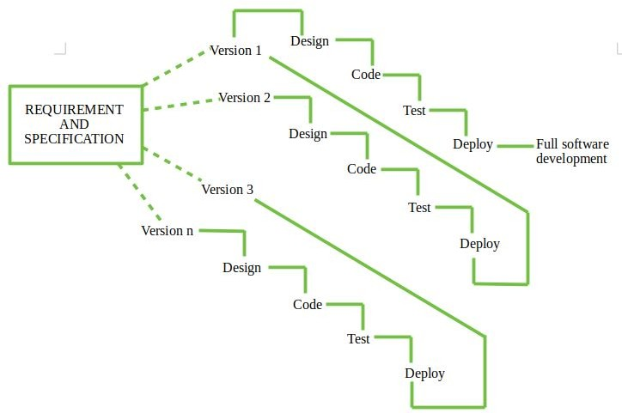

##### Project Scheduling

* + 1. **System Phases**

Analysis



It consist of three part’s :

* + - * System Analysis
      * Requirement Analysis
      * Defining Project Scope

In this stage the requirement for both system and software are documented and reviewed with customer. To understand the nature of the program to built one must understand the nature of the program one must understand the information domain for software as well as required function, behavior, performance, and interface.

##### Designs



It consists of 4 subtasks:

* Preparing the UML diagrams.
* Database Design and modularization
* Prototype Design
* Prototype Acceptance

In this stage, the database is designed after preparing the UML diagrams which include ER diagrams, DFD, Object Diagrams etc. In E-Classified the backend tool used is Microsoft SQL Server 2005, which is an easy tool to work with. The modularization of the entire project takes place after the database design and each individual was allotted the work. She is supposed to complete. After the database design and modularization comes the prototype design subtask. In this task, the prototype is first prepared i.e. The User interface design is first prepared and final task in the phase is prototype acceptance in which the project leader and then the client approves or rejects the prototype, If the design is approved then the project is proceeded further

Coding



It consists of two subtasks:

* Coding Conventions
* Coding

In this phase, the coding of the project is performed after the acceptance of the prototype by the project leader and then the customer. Coding conventions are followed which makes it easier to recognize the data fields. For example: In EClassified we have followed coding conventions for the data fields as 'i' precedes the data field in case of an Integer; 'v' precedes the field if it's a varchar type etc., after following coding conveyance the coding is performed.

##### System Integration



As the system is divided into many modules, the integration is to be performed at the end of the coding phase of each module. All the testing to be performed for the entire system is performed in the next phase

##### Documentation



This phase consists of two subtasks:

* + User Manuals
  + Technical Documentation

User Manuals are prepared which guides the user is accessing the software. The technical documentation and trainee manuals are also prepared along with user manuals.

##### 4.3.1 TimeLine Chart

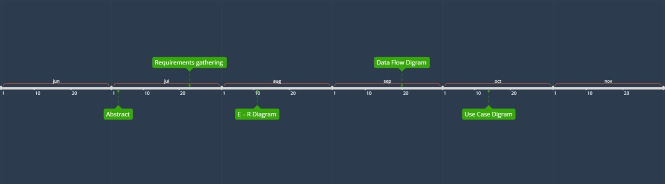

Semester - 5

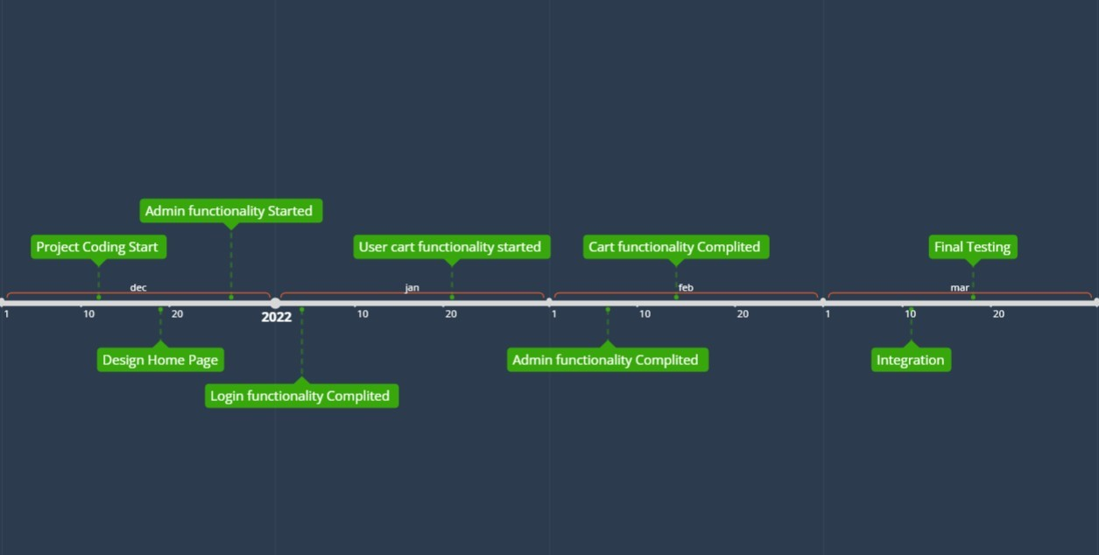

Semester - 6

## Software Requirement Specification

* 1. User Of the System
     + **Admin**
     + Customer
  2. **Admin Point Of View:**
     + Manage Products
     + Manage Supplier
     + Manage Supplier order
     + Manage Admin data
     + Manage Supplier bill

Customer Point Of View:

* + - Manage Customer data
    - Manage Order data
    - Manage Cart data

General Point Of View:

* + - Customer Authentication
    1. **Admin Point of view:**

##### Manage Product related data

* + - * + Add Product

Add/Insert Products

Input :- about new Product

Output :- Acknowledgement Message

* + - * + Modify Product

Modification of Products related data

Input :- Search Keyword , modification

Output :- Acknowledgement Message

* + - * + Remove Product

Removing Product related data

Input:- Search Keyword

Output:- Acknowledgement Message

* + - * + Search Product

Searching the Product by Keyword

Input:-Search Keyword

Output:- Product related data

##### Manage Supplier related data

* + - * + Add Supplier:

Adds/Insert Supplier related data

Input:-Data related to new Supplier

Output:- Acknowledgement Message

* + - * + Modify Supplier

Modify Supplier related data

Input :- Search Keyword , Modification

Output:- Acknowledgement Message

* + - * + Remove Supplier

Removing Supplier related data

Input:- Search Keyword

Output:- Acknowledgement Message

* + - * + Search Supplier

Searching the Supplier by Keyword

Input:-Search Keyword

Output:- Supplier related data

##### Manage Supplier order related data

* + - * + Add Supplier order:

Adds/Insert Supplier order related data

Input:-Data related to new Supplier order

Output:- Acknowledgement Message

* + - * + Modify Supplier order

Modify Supplier order related data

Input :- Search Keyword , Modification

Output:- Acknowledgement Message

* + - * + Remove Supplier order

Removing Supplier order related data

Input:- Search Keyword

Output:- Acknowledgement Message

* + - * + Search Supplier order

Searching the Supplier order by Keyword

Input:-Search Keyword

Output:- Supplier order related data

##### Manage Admin related data

* + - * + Add Admin:

Adds/Insert Admin related data

Input:-Data related to new Admin

Output:- Acknowledgement Message

* + - * + Modify Admin

Modify Admin related data

Input :- Search Keyword , Modification

Output:- Acknowledgement Message

* + - * + Remove Admin

Removing Admin related data

Input:- Search Keyword

Output:- Acknowledgement Message

* + - * + Search Admin

Searching the Admin by Keyword

Input:-Search Keyword

Output:- Admin related data

##### Manage Supplier Bill related data

* + - * + Add Supplier bill:

Adds/Insert Supplier bill related data

Input:-Data related to new Supplier order

Output:- Acknowledgement Message

* + - * + Modify Supplier bill

Modify Supplier bill related data

Input :- Search Keyword , Modification

Output:- Acknowledgement Message

* + - * + Remove Supplier bill

Removing Supplier bill related data

Input:- Search Keyword

Output:- Acknowledgement Message

* + - * + Search Supplier bill

Searching the Supplier bill by Keyword

Input:-Search Keyword

Output:- Supplier bill related data

#### Customer Point of view :

* + - * **Manage Customer related data**
        + Add Customer:

Adds/Insert Customer related data

Input:-Data related to new Customer

Output:- Acknowledgement Message

* + - * + Modify Customer

Modify Customer related data

Input :- Search Keyword , Modification

Output:- Acknowledgement Message

* + - * + Remove Customer

Removing Customer related data

Input:- Search Keyword

Output:- Acknowledgement Message

* + - * + Search Customer

Searching the Customer by Keyword

Input:-Search Keyword

Output:- Customer related data

* + - * **Manage Order related data**
        + Add Order:

Adds/Insert Order related data

Input:-Data related to new Order

Output:- Acknowledgement Message

* + - * + Modify Order

Modify Order related data

Input :- Search Keyword , Modification

Output:- Acknowledgement Message

* + - * + Remove Order

Removing Order related data

Input:- Search Keyword

Output:- Acknowledgement Message

* + - * + Search Order

Searching the Order by Keyword

Input:-Search Keyword

Output:- Order related data

* Cancel Order
  + Customer can cancel order.
  + Input:- Search keyword.
  + Output:- Cancellation Status/Status update data

##### Manage Cart related data

* + - * + Add Cart:

Adds/Insert Cart related data

Input:-Data related to Cart

Output:- Acknowledgement Message

* + - * + Modify Cart

Modify Cart related data

Input :- Search Keyword , Modification

Output:- Acknowledgement Message

* + - * + Remove Cart

Removing Cart related data

Input:- Search Keyword

Output:- Acknowledgement Message

* + - * + Search Cart

Searching the Cart by Keyword

Input:-Search Keyword

Output:- Cart related data

#### General Point of view:

##### Customer/Admin authentication:

* + - * + Login

Used to login Customer/Admin

Input:- Customer_id or Admin_id and Password

Output:- Acknowledgement Message

## System Design

#### Design Principles

System design is the process of defining the elements of a system such as the architecture, modules and components, the different interfaces of those components and the data that goes through that system. It is meant to satisfy specific needs and requirements of a business or organization through the engineering of a coherent and well-running system**.**

##### Should not suffer from “Tunnel Vision” –

While designing the process, it should not suffer from “tunnel vision” which means that is should not only focus on completing or achieving the aim but on other effects also.

##### Traceable to analysis model –

The design process should be traceable to the analysis model which means it should satisfy all the requirements that software requires to develop a high-quality product.

##### Should not “Reinvent The Wheel” –

The design process should not reinvent the wheel that means it should not waste time or effort in creating things that already exist.

Due to this, the overall development will get increased.

##### Minimize Intellectual distance –

The design process should reduce the gap between real-world problems and software solutions for that problem meaning it should simply minimize intellectual distance**.**

##### Exhibit uniformity and integration –

The design should display uniformity which means it should be uniform throughout the process without any change. Integration means it should mix or combine all parts of software i.e. subsystems into one system.

##### Accommodate change –

The software should be designed in such a way that it accommodates the change implying that the software should adjust to the change that is required to be done as per the user’s need.

##### Degrade gently –

The software should be designed in such a way that it degrades gracefully which means it should work properly even if an error occurs during the execution.

##### Assessed or quality –

The design should be assessed or evaluated for the quality meaning that during the evaluation, the quality of the design needs to be checked and focused on.

##### Review to discover errors –

The design should be reviewed which means that the overall evaluation should be done to check if there is any error present or if it can be minimized.

##### Design is not coding and coding is not design –

Design means describing the logic of the program to solve any problem and coding is a type of language that is used for the implementation of a design.

#### Use Case Diagram

A use case diagram is used to represent the dynamic behavior of a system. It encapsulates the system's functionality by incorporating use cases, actors, and their relationships. It models the tasks, services, and functions required by a system/subsystem of an application. It depicts the high-level functionality of a system and also tells how the user handles a system.



Purpose of Use Case Diagrams :



* + - The main purpose of a use case diagram is to portray the dynamic aspect of a system. It accumulates the system's requirement, which includes both internal as well as external influences. It invokes persons, use cases, and several things that invoke the actors and elements accountable for the implementation of use case diagrams. It represents how an entity from the external environment can interact with a part of the system.
    - Following are the purposes of a use case diagram given below:
      * It gathers the system's needs.
      * It depicts the external view of the system.
      * It recognizes the internal as well as external factors that influence the system.
      * It represents the interaction between the actors.

#### Symbols used for Use Case Diagram :

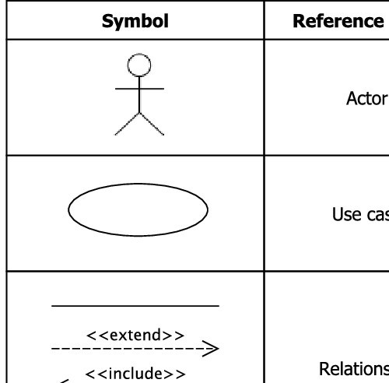

* **Use Case Diagram Of Project**

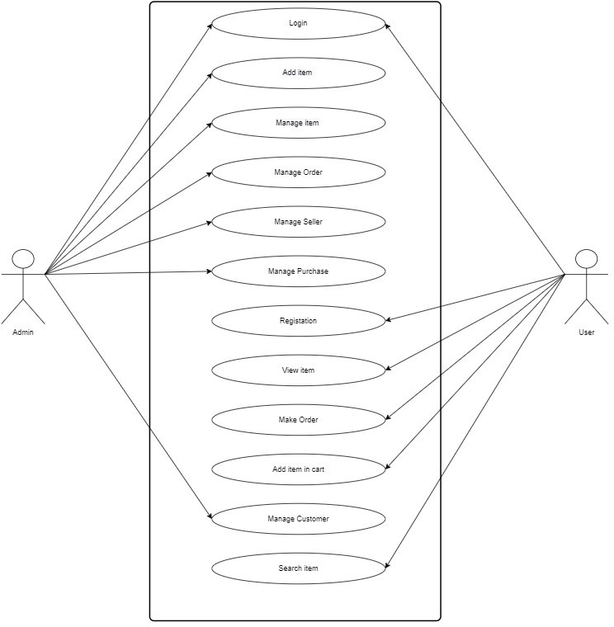

#### Entity Relationship Diagram :

* + 1. **Entity sets**

|  |  |
| --- | --- |
| **Entity Sets** | **Attributes** |
| Customer | Cust_id, First_name , Last_Name , Password ,  Address , Gender , e-mail , phone_no |
| Admin | Admin_id,First_name,Last_Name,Address,Gender,e- mail, Password,  phone_no |
| Products | Pro_id ,Prod_name , Prod_brand , Prod_Cat ,  Prod_price , Prod_qty , Prod_img , Prod_discreption |
| Cart | Cart_id ,Cust_id |
| C_bill | Order_id, Cust_id,Prod_id,Prod_qty,Order_date ,  Total_Cost,address |
| Supplier | Suplier_id, Suplier_name , Suplier_address ,  Sup_cont , Sup_email |
| SBill | SBno, SBdate , total_cost |
| Cart_item | Cart_id,Prod_id |
| cat | Cat_id,catname |

#### Associations

|  |  |  |  |  |  |  |  |  |
| --- | --- | --- | --- | --- | --- | --- | --- | --- |
|  | **Customer** | **Admin** | **Products** | **Cart** | **C_bill** | **Supplier** | **SBill** | **SOrder** |
| **Customer** | X | X | X | ✅ | ✅ | X | X | X |
| **Admin** | X | X | X | X | X | X | X | X |
| **Products** | X | X | X | ✅ | ✅ | X | ✅ | ✅ |
| **Cart** | ✅ | X | X | X | X | X | X | X |
| **C_bill** | ✅ | X | ✅ | ✅ | X | X | X | X |
| **Supplier** | X | X | X | X | X | X | ✅ | ✅ |
| **SBill** | X | X | ✅ | X | X | ✅ | X | X |
| **Cart_item** | X | X | ✅ | X | X | X | X | X |
| **cat** | X | X | ✅ | X | X | X | X | X |

* + 1. **Relationship sets**

|  |  |  |
| --- | --- | --- |
| **Entity Set** | **Relationship Set** | **Mapping Cardinality** |
| Customer-C_Bill | CBill | One-Many |
| Customer-Cart | CCart | One-One |
| Product-Cart_item | PCart_item | Many-Many |
| C_Bill-Product | CBillProduct | Many-Many |
| Product-SBill | PSbill | Many-Many |
| Cart-cart_item | CCitem | One-Many |
| Product-cat | Pcat | Many-One |
| Cart-C_Bill | CCBill | One-Many |
| Supplier-SBill | SSbill | One-Many |

|  |  |  |
| --- | --- | --- |
| Supplier-Product | SProduct | One-Many |

#### ER Diagram

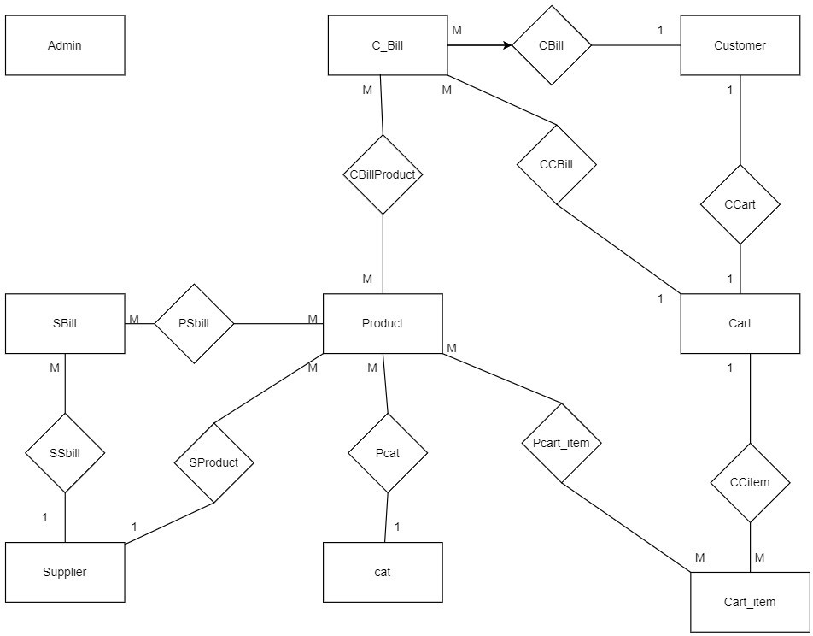

* + 1. **Relationship Schema**

|  |  |
| --- | --- |
| **Entity** | **Attributes** |
| **Customer** | **Cust_id** , First_Name , Last_Name , Password ,  Address , Gender , e-mail , Phone_no |
| **Admin** | **Admin_id** , First_Name , Last_Name , Password  , Address , Gender , e-mail , Phone_no |
| **Products** | **Pro_id** , Prod_name , Prod_Brand , Prod_Cat , Prod_price , Prod_qty , Prod_img ,  Prod_Discreption |
| **Cart** | **Cart_id** , Cust_id |
| **Cart_item** | **Cart_id,**Product_id |
| **Cbill** | **Order_id** , Cust_id , Cart_id , Order_date ,  Total_cost |
| **Supplier** | **Suplier_id** , Suplier_name , Suplier_add ,  Suplier_cont , Sup_email |
| **SBill** | **SBno** , Suplier_id , SBdate , Total_cost |
| **cate** | **Cate_id** , Catename |
| **CartProduct** | **Prod_id , Cart_id** , Total_Cost |
| **CBillProduct** | **Prod_id , Order_id** , qty , Total_cost |
| **PSBill** | **Prod_id , SBno** , qty , Total_Cost |

#### Data Dictionary

##### Customer :

|  |  |  |  |  |
| --- | --- | --- | --- | --- |
| **Col - Name** | **Type** | **Size** | **Constraint** | **Represents** |
| Cust_id | NUMBER | 6 | PRIMARY  KEY | Customer Id |
| First_name | VARCHAR2 | 20 |  | Customer First  Name |
| Last_name | VARCHAR2 | 20 |  | Customer Last  Name |
| Password | VARCHAR2 | 12 | NOT  NULL | Customer  Password |
| Address | VARCHAR2 | 100 |  | Customer  Address |
| Gender | VARCHAR2 | 6 |  | Customer  Gender |
| e-mail | VARCHAR2 | 50 |  | Customer E-  mail |
| Phone_no | NUMBER | 12 |  | Customer  Mobile no |

**Admin:**

|  |  |  |  |  |
| --- | --- | --- | --- | --- |
| **Col - Name** | **Type** | **Size** | **Constraint** | **Represents** |
| Admin_id | NUMBER | 6 | PRIMARY  KEY | Admin Id |
| First_name | VARCHAR2 | 20 |  | Admin First  Name |
| Last_name | VARCHAR2 | 20 |  | Admin Last  Name |

|  |  |  |  |  |
| --- | --- | --- | --- | --- |
| Password | VARCHAR2 | 12 | NOT  NULL | Admin  Password |
| Address | VARCHAR2 | 100 |  | Admin Address |
| Gender | VARCHAR2 | 6 |  | Admin Gender |
| e-mail | VARCHAR2 | 50 |  | Admin E-mail |
| Phone_no | NUMBER | 12 |  | Admin Mobile  no |

#### Product :

|  |  |  |  |  |
| --- | --- | --- | --- | --- |
| **Col - Name** | **Type** | **Size** | **Constraint** | **Represents** |
| Prod_id | NUMBER | 6 | PRIMARY  KEY | Product Id |
| Prod_name | VARCHAR2 | 30 |  | Product  Name |
| Prod_Brand | VARCHAR2 | 20 |  | Product  Brand |
| Prod_Cat | VARCHAR2 | 20 |  | Product  Catogery |
| Prod_Price | NUMBER | 7 |  | Product  Price |
| Prod_qty | NUMBER | 5 |  | Product  Quantity |
| Prod_img | VARCHAR2 |  |  | Product  image |
| Prod_discreption | VARCHAR2 | 200 |  | Product  Discreption |

##### Cart :

|  |  |  |  |  |
| --- | --- | --- | --- | --- |
| **Col - Name** | **Type** | **Size** | **Constraint** | **Represents** |
| Cart_id | NUMBER | 6 | PRIMARY  KEY | CartId |
| Cust_id | NUMBER | 6 | FOREIGN  KEY | Customer id |

**CBill :**

|  |  |  |  |  |
| --- | --- | --- | --- | --- |
| **Col - Name** | **Type** | **Size** | **Constraint** | **Represents** |
| Cbill_id | NUMBER | 6 | PRIMARY  KEY | Customer Bill  Id |
| Cust_id | NUMBER | 6 | FOREIGN  KEY | Customer Id |
| Prod_id | VARCHAR2 | 100 |  | Product id |
| Prod_qty | VARCHAR2 | 100 |  | Product Qty |
| Order_date | DATE |  |  | Order Date |
| Total_Cost | NUMBER | 7 |  | Total Cost of  Order |

##### Supplier :

|  |  |  |  |  |
| --- | --- | --- | --- | --- |
| **Col - Name** | **Type** | **Size** | **Constraint** | **Represents** |
| Supplier_id | NUMBER | 6 | PRIMARY  KEY | Supplier id |
| Supplier_name | VARCHAR2 | 40 |  | Supplier name |
| Supplier_add | VARCHAR2 | 100 |  | Supplier  Address |
| Supplier_cont | VARCHAR2 | 12 |  | Supplier  Contact No |
| Suplier_email | VARCHAR2 | 50 |  | Supplier  Email |

**SBill :**

|  |  |  |  |  |
| --- | --- | --- | --- | --- |
| **Col - Name** | **Type** | **Size** | **Constraint** | **Represents** |
| Sbill_no | NUMBER | 6 | PRIMARY  KEY | Supplier Bill no |
| Suplier_id | NUMBER | 6 | FOREIGN  KEY | Supplier id |

|  |  |  |  |  |
| --- | --- | --- | --- | --- |
| SBDate | DATE |  |  | Supplier Bill  Date |
| Total_Cost | NUMBER | 7 |  | Total cost of  Supplier Bill |

##### Cart_item :

|  |  |  |  |  |
| --- | --- | --- | --- | --- |
| **Col - Name** | **Type** | **Size** | **Constraint** | **Represents** |
| Cart_id | NUMBER | 6 | PRIMARY  KEY | Cart id |
| Prod_id | NUMBER | 6 | FOREIGN  KEY | Product id |

**PSBill :**

|  |  |  |  |  |
| --- | --- | --- | --- | --- |
| **Col - Name** | **Type** | **Size** | **Constraint** | **Represents** |
| Product_id | NUMBER | 6 | PRIMARY  KEY | Product id |
| SBno | NUMBER | 6 | PRIMARY  KEY | Supplier Bill no |
| Qty | NUMBER | 5 |  | Quntity of  Product |
| Total_Cost | NUMBER | 7 |  | Total cost |

##### Cate :

|  |  |  |  |  |
| --- | --- | --- | --- | --- |
| **Col - Name** | **Type** | **Size** | **Constraint** | **Represents** |
| Cate_id | NUMBER | 6 | PRIMARY  KEY | Category id |
| Cate_name | VARCHAR2 | 6 |  | Category name |

**PCBill :**

|  |  |  |  |  |
| --- | --- | --- | --- | --- |
| **Col - Name** | **Type** | **Size** | **Constraint** | **Represents** |
| Product_id | NUMBER | 6 | PRIMARY  KEY | Product id |
| Cart_id | NUMBER | 6 | PRIMARY  KEY | Cart id |
| Total_cost | NUMBER | 7 |  | Total Cost |

**CBillProduct :**

|  |  |  |  |  |
| --- | --- | --- | --- | --- |
| **Col – Name** | **Type** | **Size** | **Constraint** | **Represents** |
| Product_id | NUMBER | 6 | PRIMARY  KEY | Product id |
| Order_id | NUMBER | 6 | PRIMARY  KEY | Order id |
| Qty | NUMBER | 5 |  | Quntity |
| Total_cost | Number | 7 |  | Total Cost |

* + 1. **Dataflow Diagram**

**Context Level(0) Digram :-**

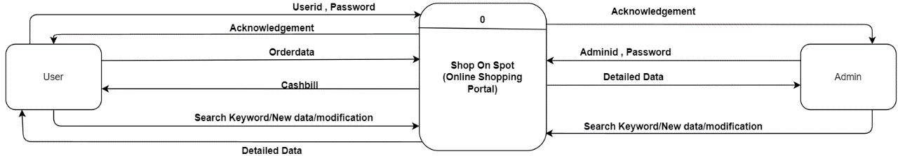

**Level 1 Diagrams :-**

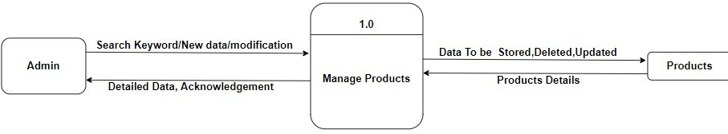

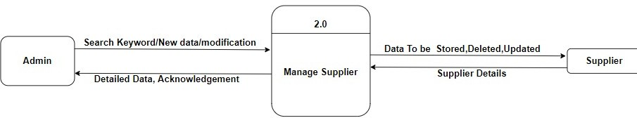

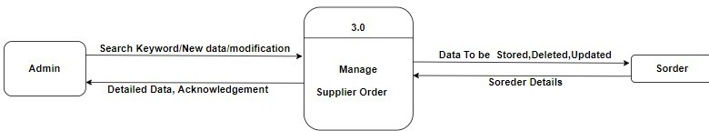

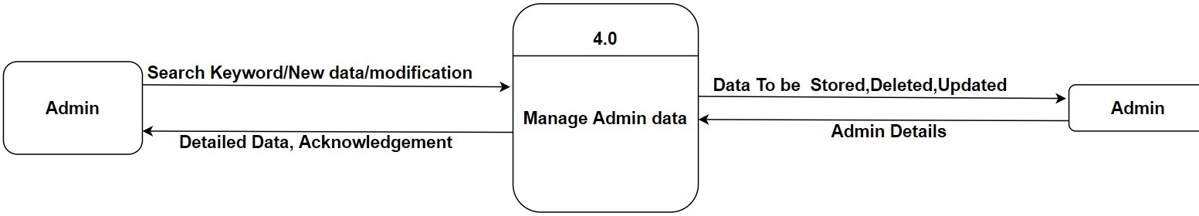

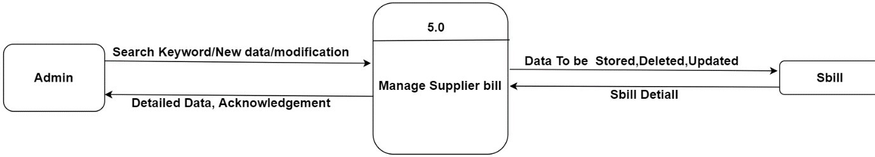

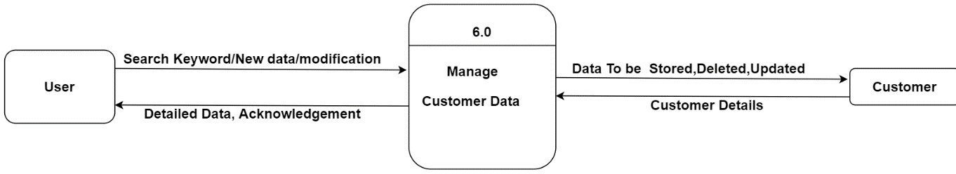

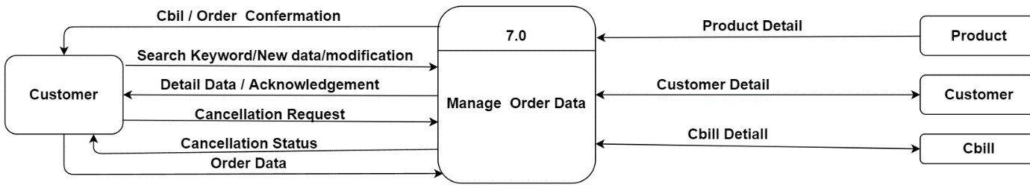

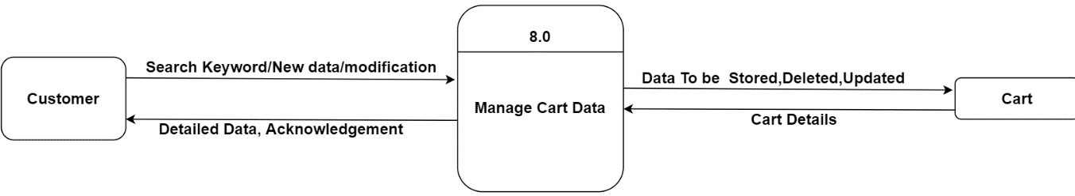

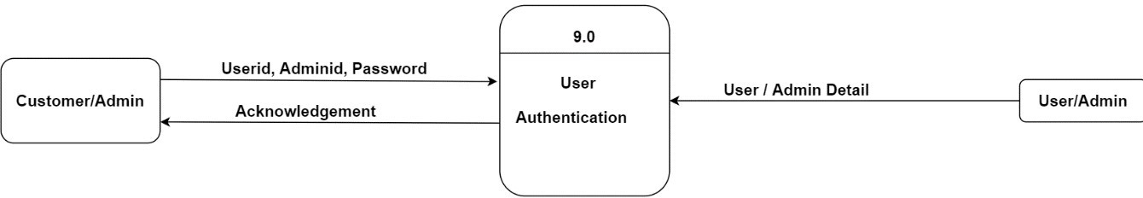

### Level 2 Diagrams :-

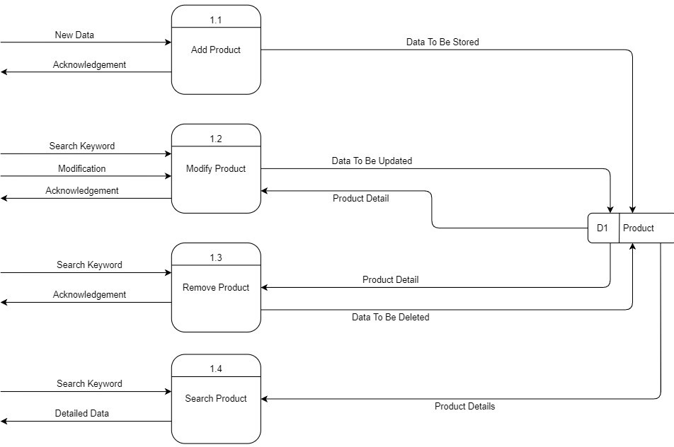

* **Note: Process 2.0 to 6.0 and 8.0 are Similar to process 1.0**

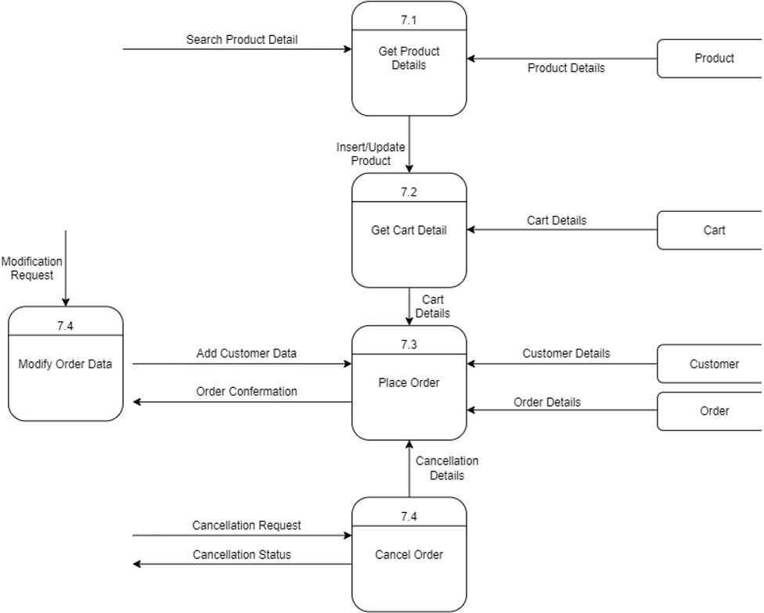

##### Process 7.0

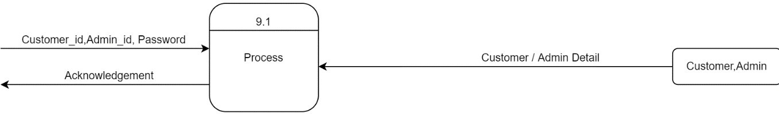

**Process 9.0**

* 1. **System Outputs:**
     1. **Home Page**

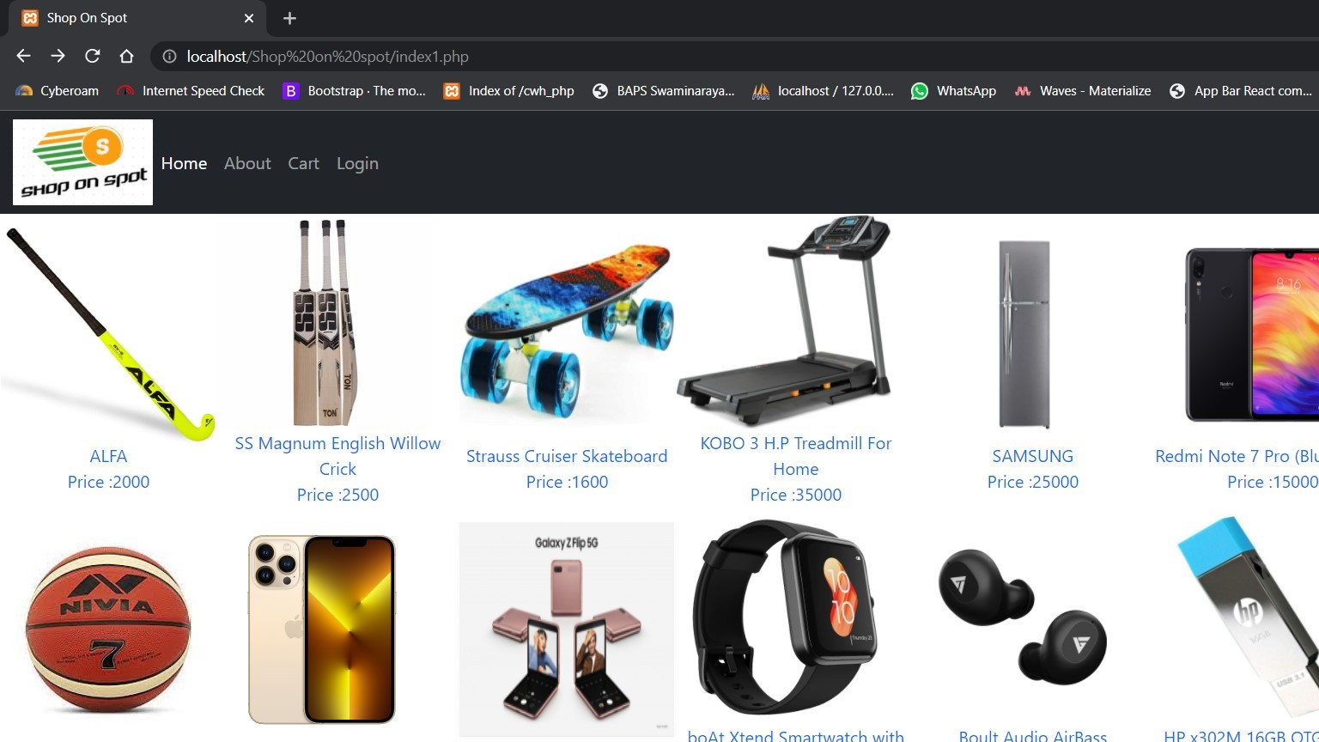

#### Product Details

* + - * **When click on any product.**

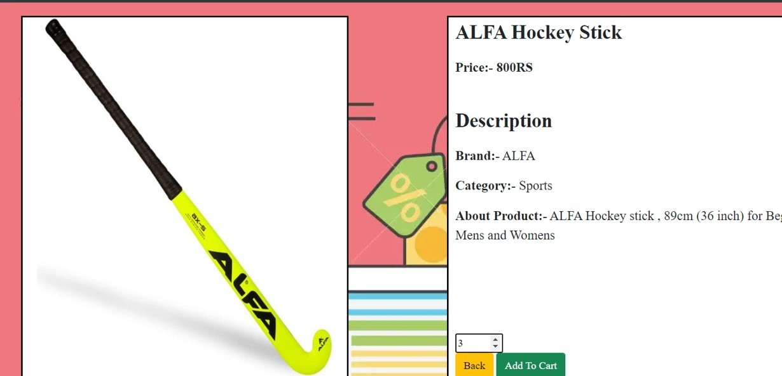

#### Registration , Login and Admin Login

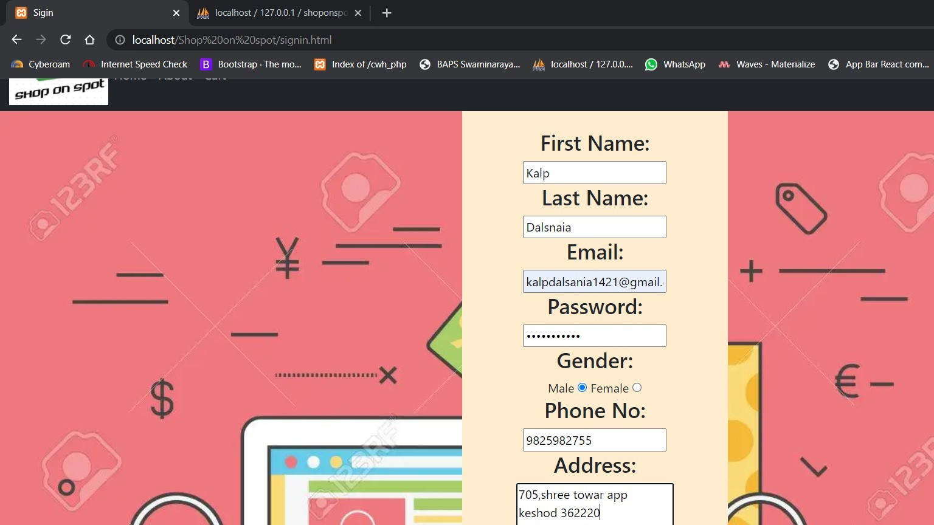

* + - * **Customer must register here in this page.**

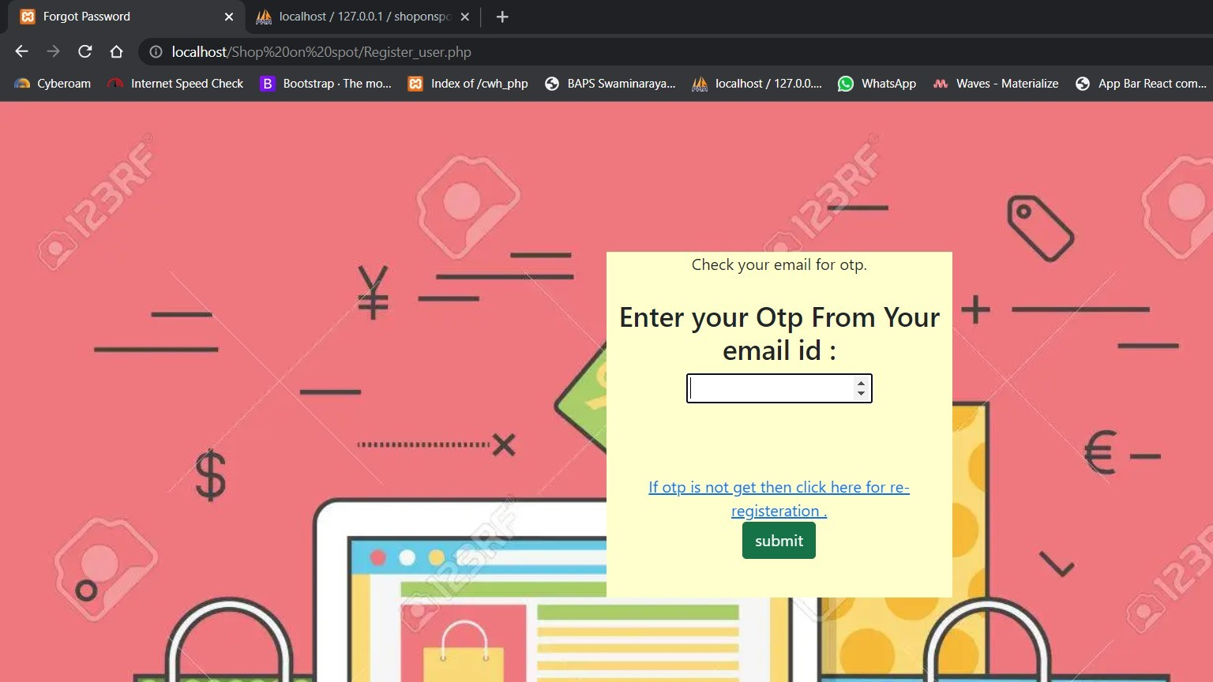

#### Cutomer must enter OTP recived in email for verification.

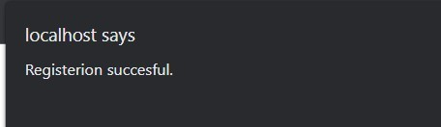

##### This message will appear when user register successfully.

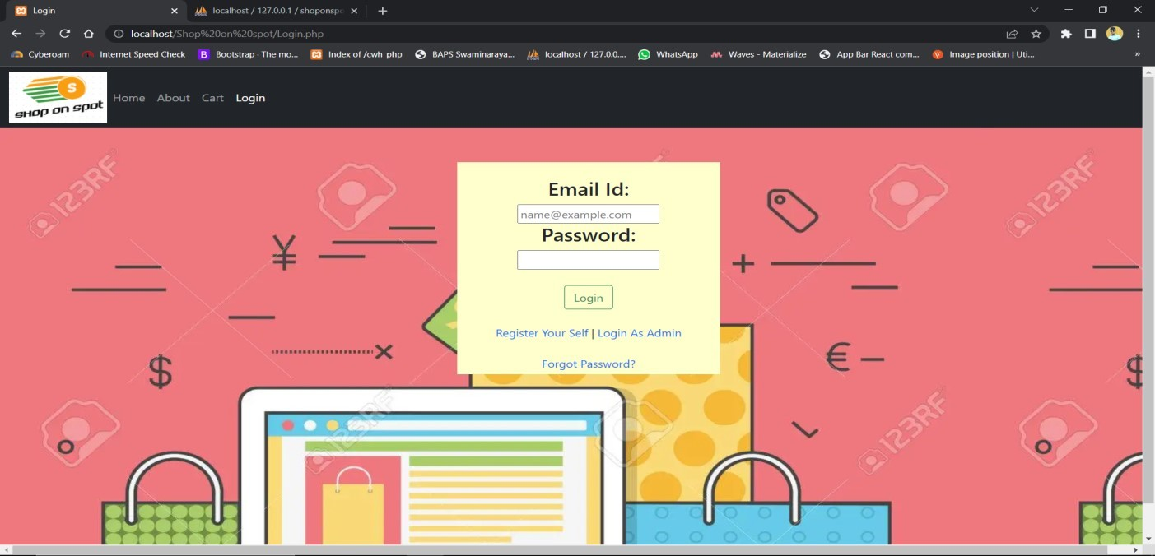

* + - * **Customer login from here.**

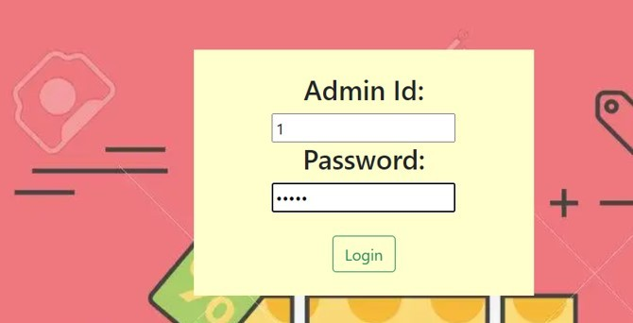

* + - * **Admin login from here.**

#### Cart Functionallty

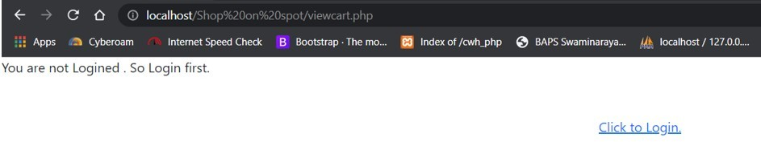

* + - * **If user is not Logged In(While using the Cart)**

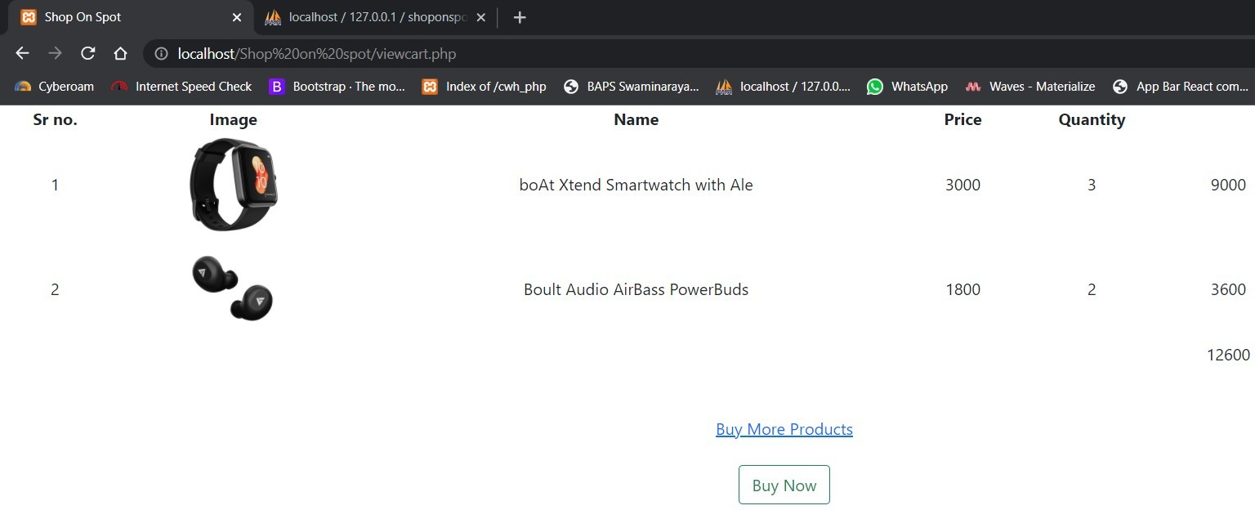

#### If user clicks Buy more Product it will redirect them to home page.And if user clicks on Buy Now Button the Order will be placed .

* + 1. **Procedure for buying product**

#### In the privous shown screen if user click’s “Buy Now” button following procedure will be continued .

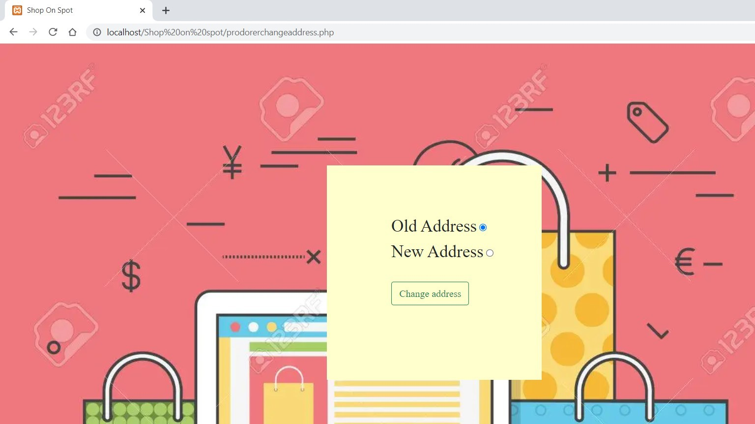

* + - * **If user want to add new address he/she must have to select second option .**

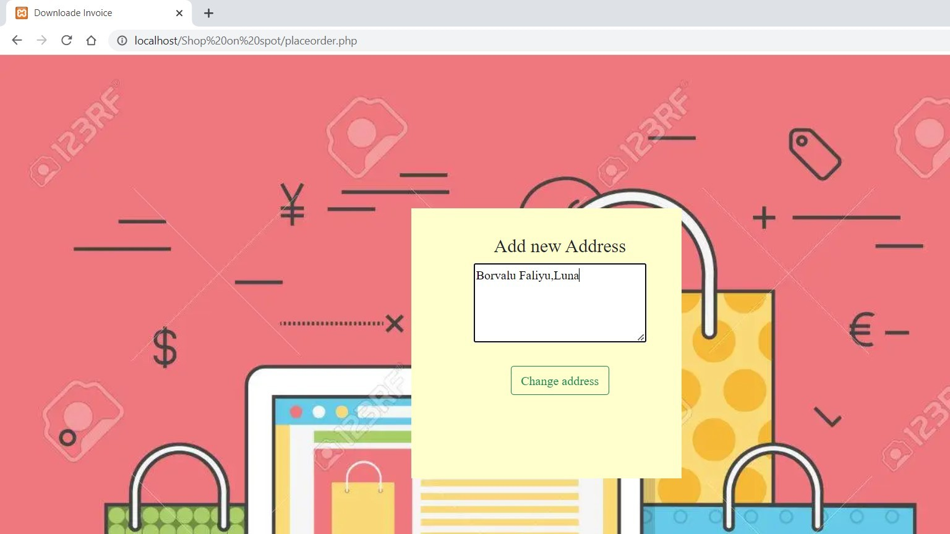

#### User must enter new address in this screen and “Change address” button is clicked then following screen will appears .

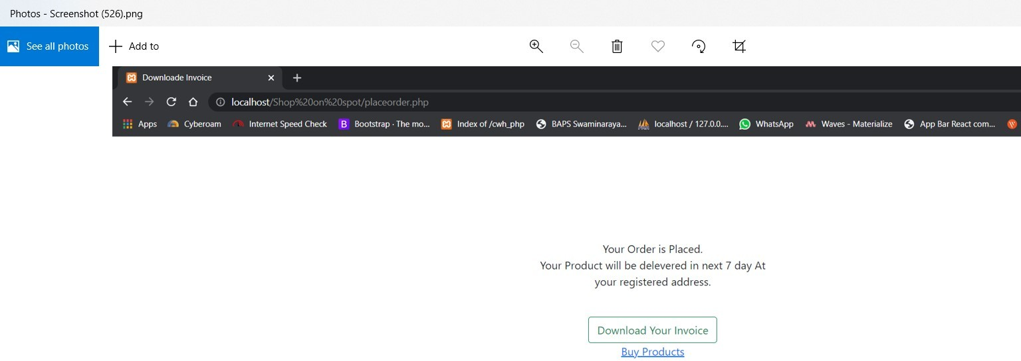

* + - * **If this screen appers then customer order is placed and brief confermation email of order will be sent to customer.**

#### If “Download invoice” button is clicked Invoice will be generated.

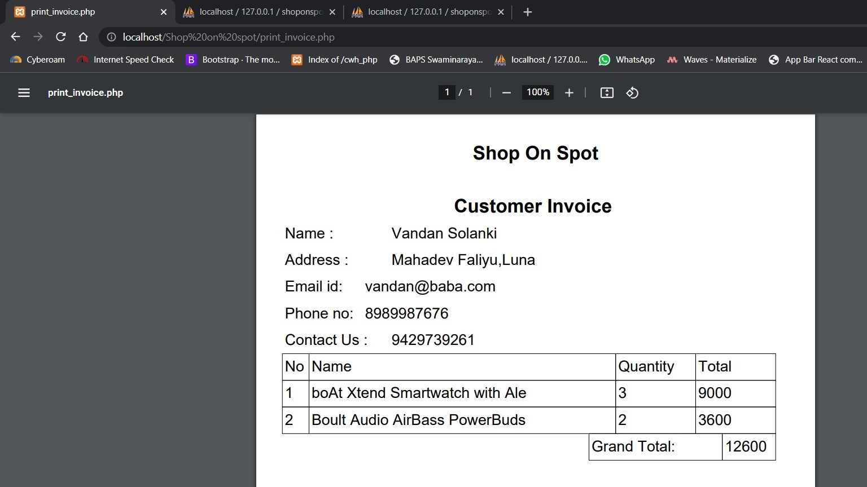

* + 1. **Admin panel**

#### Admin home page

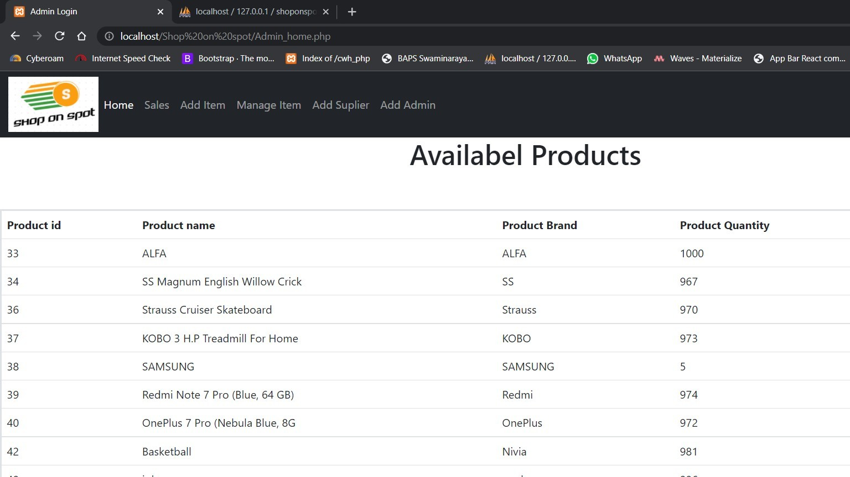

* **In this page the details of avalibel stock will be shown . If pressed ‘Download Inventory Details’ button the above detail will be print in pdf formet.**

#### Sales

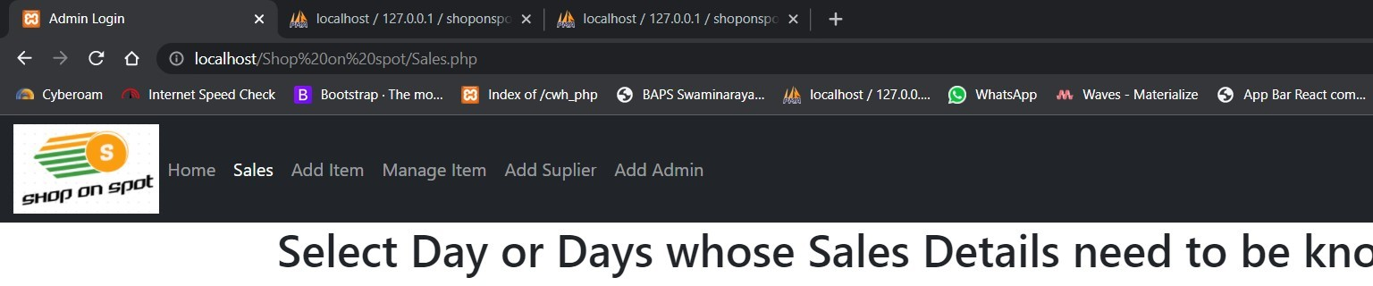

* **If the ‘today’ option is selected then today’s all sales will be showen.**

#### If the ‘Between two dates’ option is selected then new screen will be shown where admin will select the two dates and the sales between that day’s will be shown.

* **If the ‘Specific Date’ option is selected then new screen will be shown where admin will select the Specific dates and the sales of that day will be shown.**

#### Add Item

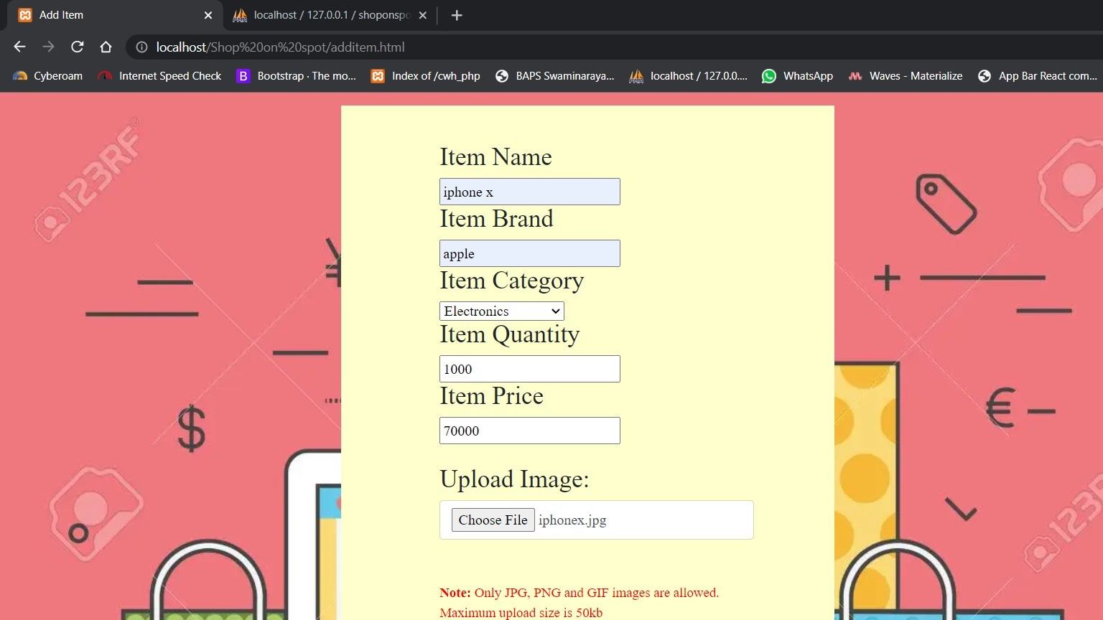

* **Item can be added by filling out of this form.**

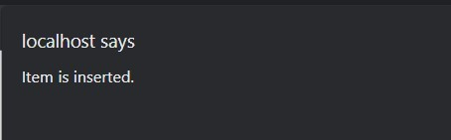

#### After adding item this confermation message will be shown.

* + - 1. **Manage Item**

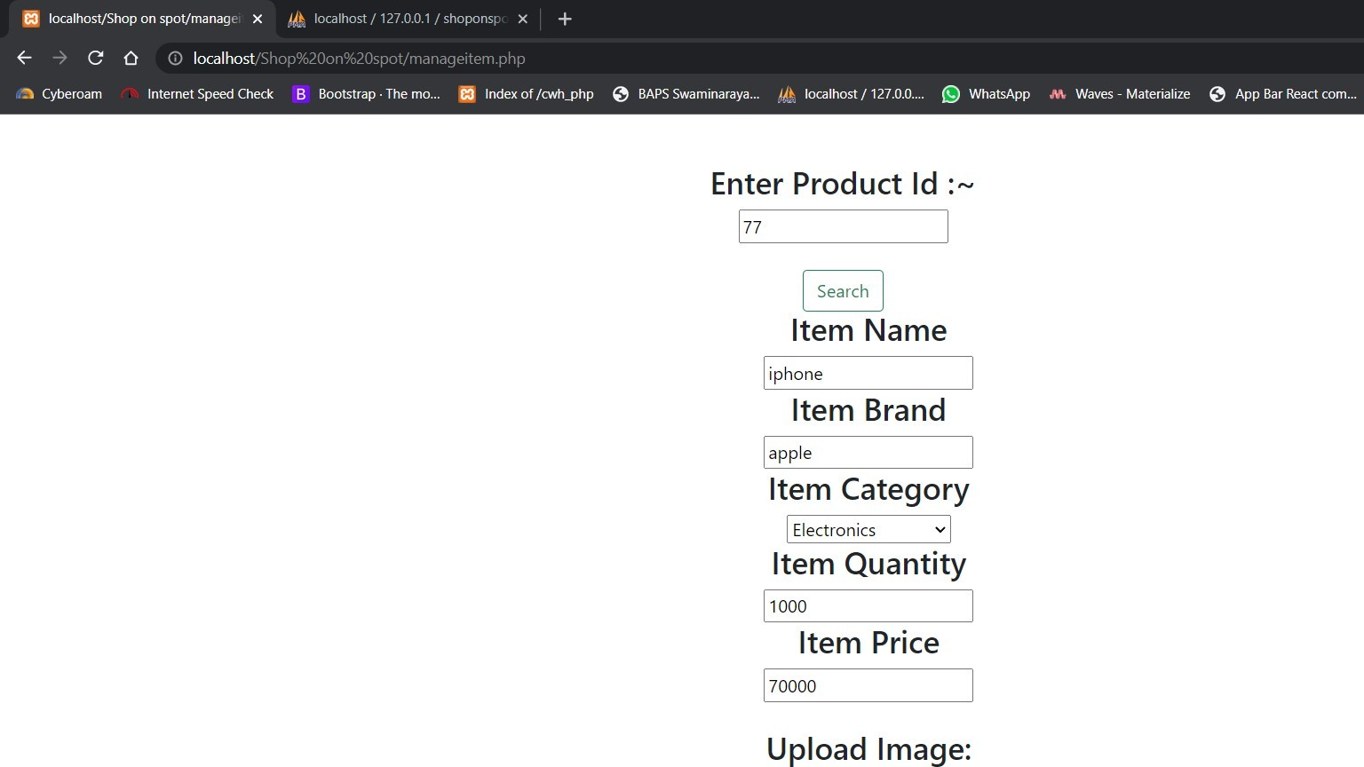

#### For managing item admin will insert item id and click the ‘search’ button then the item details will be shown .

* **Here admin can change the item details if wanted to change.**

#### Add Supplier

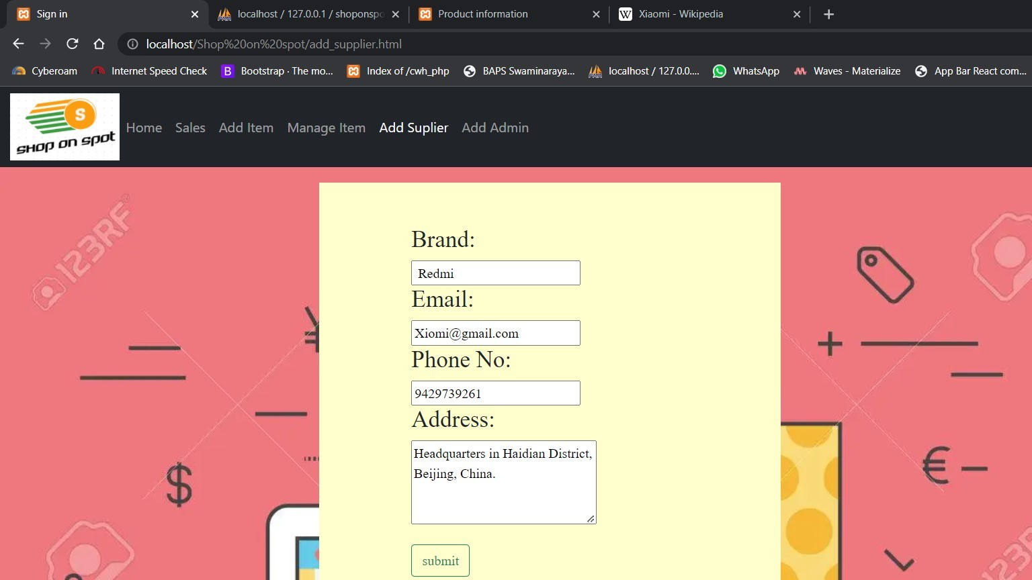

* **For Add new supplier admin can insert supplier details .**

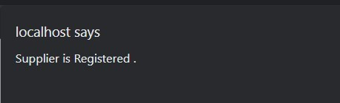

#### After adding new supplier this confermation message will be shown.

* + - 1. **Add Admin**

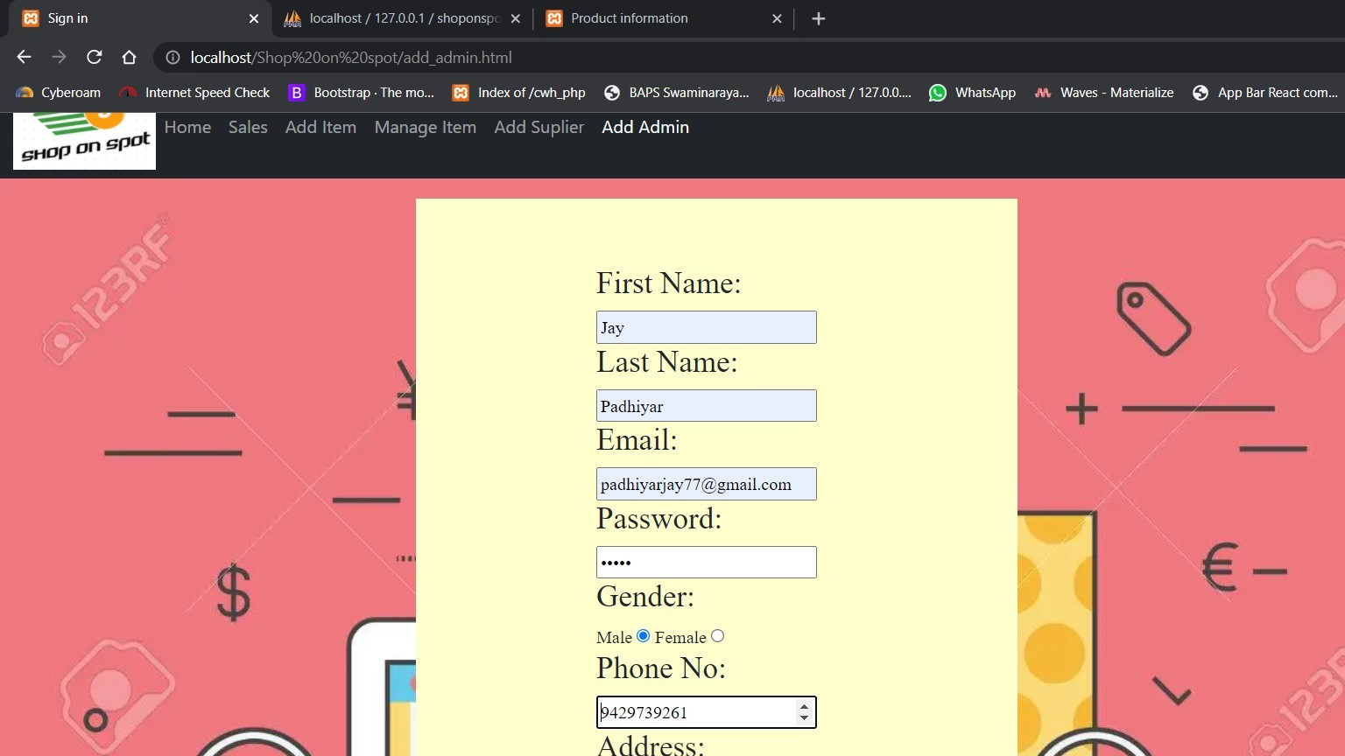

#### For create new admin the main admin can insert admin details .

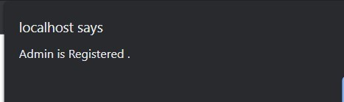

* **After adding new admin this confermation message will be shown.**

#### 6.6.6.5 Add new Category

* **For create new category the admin will insert category.**

#### To Logout admin will click the Logout button in navigation bar.

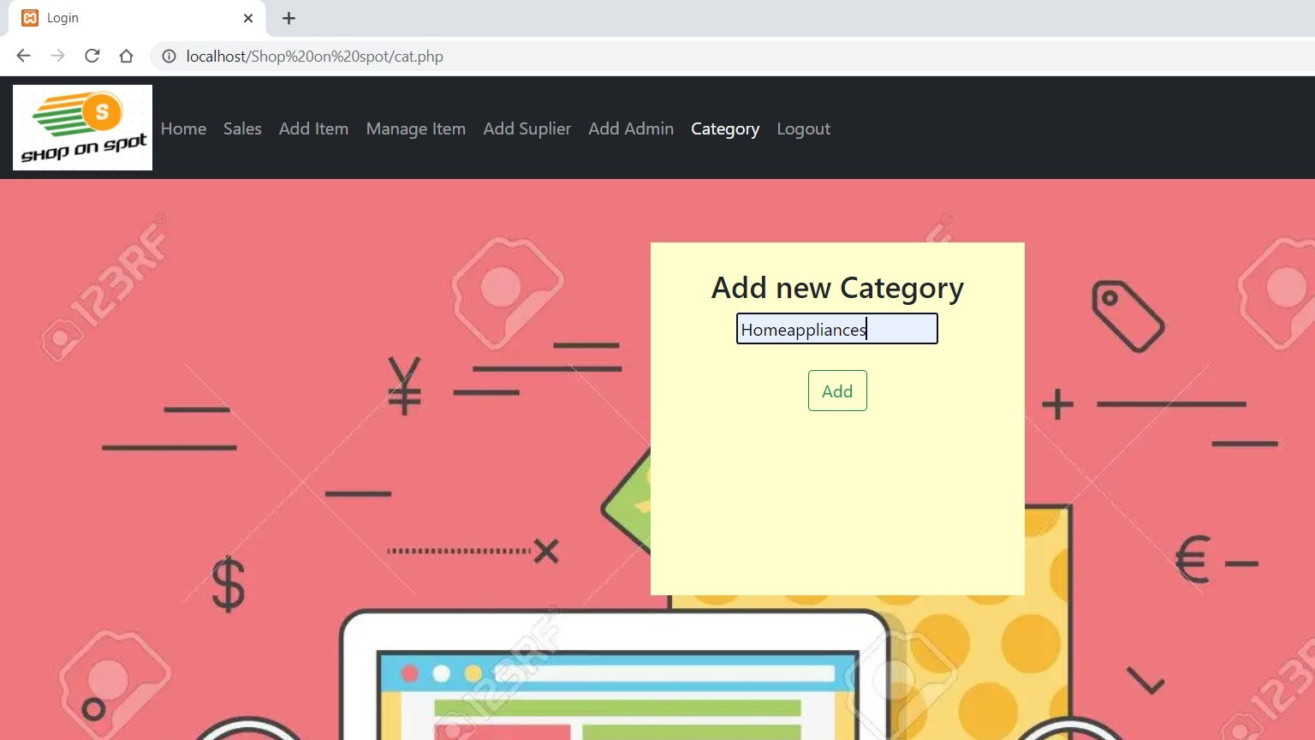

* + 1. **User Profile**

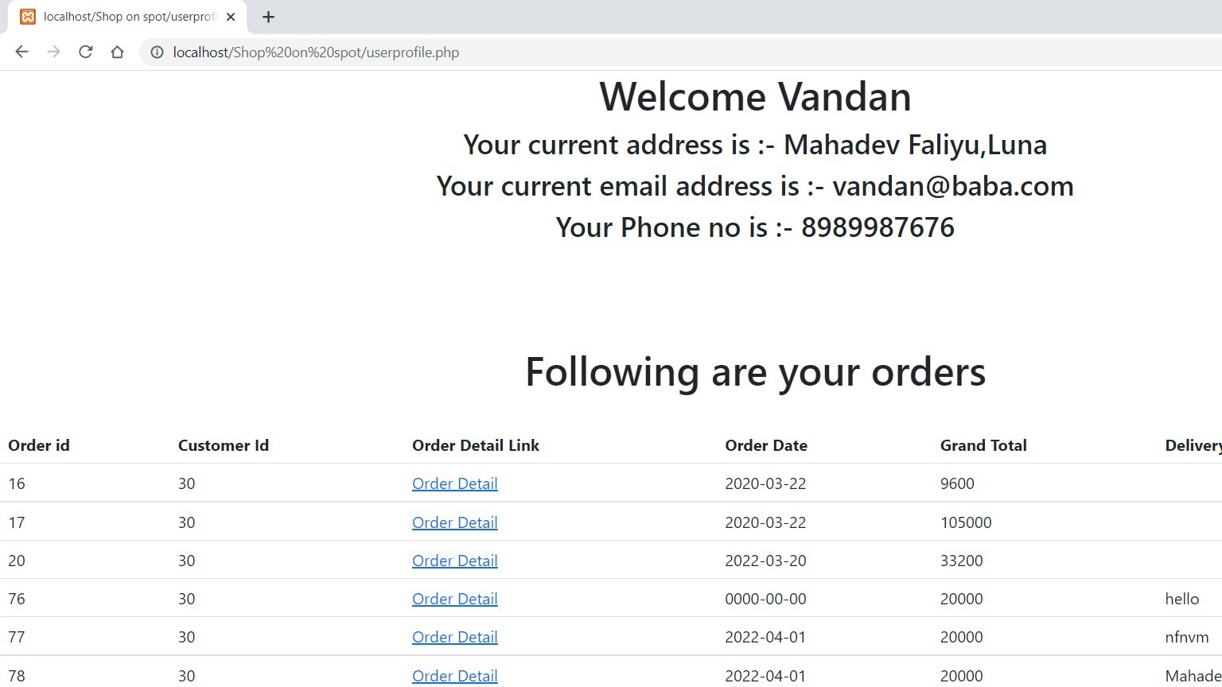

#### In User Profile user can see there detail and there placed order details.

* 1. **Limitation**

## Conclusion

* User might not like the user interface that is provided.
* At this particular cash on delivery option is there thus many user may wanted to pay online.

#### Future Enhancement

* + - Online payment gateway can be added for online payment.
    - More security related features can be added.
    - Android or IOS applications can be crated

#### Advantages

* + - The problem of going physically and buying stuff from store can be solved.
    - Customer can get any product’s which are not available in there city.
    - Customer can get chance to buy international product’s.
    - Admin can have chance to sell the product online and earn some money.

#### Learnings from project

Working on this project has provided us good experience of managing project’s , time and how to enhance our skills .

Working on this project has given us brief idea of how IT industries work’s.

We got very good experience of problem solving.

The wonderful experience of working in teem will be surely useful in future.

At the end we would like to thank to all the faculty member and all classmates who have helped us in one way or another .

## Reference

###### While Working on this Project we have taken references from sources:

* Websites :

###### https://[www.geeksforgeeks.org/](http://www.geeksforgeeks.org/) [For Database]

* + https://[www.flipkart.com/](http://www.flipkart.com/) [For Overview]

###### https://meeraacademy.com/ [For Data Flow Diagram]

* + https://[www.youtube.com/](http://www.youtube.com/)

###### https://[www.php.net/docs.php](http://www.php.net/docs.php)

* + https://getbootstrap.com/

###### https://[www.w3schools.com/](http://www.w3schools.com/)